

**A SKILL BASED EVALUATION REPORT**

**SUBMITTED BY**

**TANVIK SRI RAM REDDY (URK23CS1261)**

**COURSE CODE  
23CS2032**

**COURSE NAME**

**OBJECT ORIENTED PROGRAMMING**

**OCTOBER 2024**



**DIVISION OF COMPUTER SCIENCE AND ENGINEERING**

**SCHOOL OF ENGINEERING AND TECHNOLOGY**

**INDUSTRIAL CERTIFICATION**

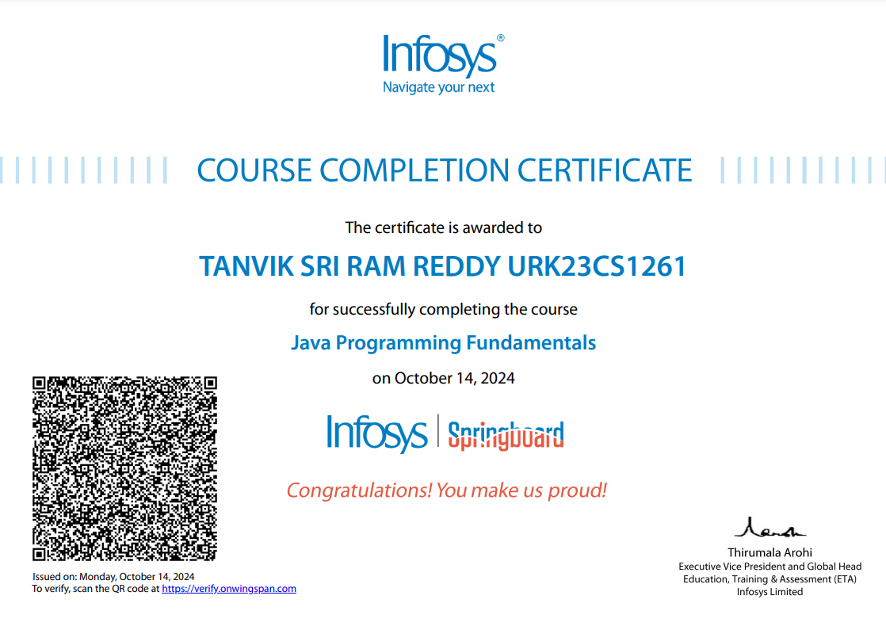

**Disaster Response Coordination**

***A REAL TIME APPLICATION REPORT***

***Submitted by***

**TANVIK SRI RAM REDDY (URK23CS1261)**



**DIVISION OF COMPUTER SCIENCE AND ENGINEERING**

**KARUNYA INSTITUTE OF TECHNOLOGY AND SCIENCES (Declared as Deemed-to-be-under Sec-3 of the UGC Act, 1956) Karunya Nagar, Coimbatore - 641 114. INDIA**

**OCTOBER 2024**

**ABSTRACT**

In times of crisis, coordinating disaster response efforts effectively can make the difference between life and death. The "Disaster Response Coordination" system is designed to streamline communication and resource allocation during emergencies. This Java-based project integrates multiple user roles—Admin, Co-Admin, Volunteer, and General User—each with distinct access privileges to ensure that the right people have the right tools to act swiftly.

The platform includes a secure sign-up and login system, allowing users to register and apply for volunteer roles. Once accepted, volunteers gain access to a dashboard, resource management tools, team coordination, and the ability to handle disaster requests. Admins and Co-Admins, who hold similar levels of control, can oversee all operations through separate dashboards, manage volunteers, allocate resources, and track active disaster scenarios.

The project's goal is to create a centralized hub where all stakeholders in a disaster response—whether government officials, volunteers, or civilians—can collaborate effectively. While some sections of the system are still under construction, the framework sets the foundation for an efficient and scalable disaster management solution.

**PROBLEM STATEMENT**

In the wake of natural disasters and emergencies, the lack of a centralized system for coordinating response efforts leads to delays in delivering aid, misallocation of resources, and communication breakdowns among volunteers, authorities, and affected communities. Existing solutions often fall short in providing real-time collaboration, role-based access, and efficient resource distribution across different levels of responsibility.

The challenge is to design and develop a comprehensive platform that allows for seamless coordination between various stakeholders, including administrators, volunteers, and general users, each with distinct roles and access privileges. The system must ensure secure user registration, volunteer management, and effective communication channels, while providing tools for organizing teams, tracking disaster responses, and allocating resources efficiently.

The solution must be scalable to accommodate multiple disaster scenarios and flexible enough to allow real-time updates, ensuring that all stakeholders have access to the latest information and can act swiftly in times of crisis.

**METHODOLOGY / ARCHITECTURE**

**Methodology**

*1. Requirements Gathering:*

The initial phase involved gathering requirements by consulting with stakeholders, including potential users and disaster response teams. This helped identify key functionalities such as user roles, sign-in and registration systems, and features for managing disaster response.

*2. System Design:*

Following requirements analysis, a detailed system design was created, encompassing the following components:

1. User Roles: Defined roles including Admin, Co-admin, Volunteer, and User, each with specific permissions.
2. Database Schema: Designed to support user management, volunteer registration, and disaster response tracking. The schema included tables for users, disasters, resources, and volunteer teams.
3. User Interface (UI) Design: Created design for the application’s UI to ensure a user-friendly experience, focusing on intuitive navigation and accessibility.

*3. Implementation:*

The implementation phase was broken down into the following key tasks:

1. Back-end Development: Utilized Java to build the application’s core functionalities, including user authentication, registration, and disaster management features.
2. Front-end Development: Developed a graphical user interface using Java Swing. The UI allowed users to easily navigate through different functionalities like disaster request management and volunteer registration.
3. Integration: Integrated front-end and back-end components, ensuring smooth data flow between the UI and the database.

*4. Testing*

Thorough testing was conducted to ensure the system's reliability and usability:

Unit Testing: Performed on individual components to validate their functionality.

Integration Testing: Ensured that different modules worked together as intended.

User Acceptance Testing (UAT): Gathered feedback from actual users to make necessary adjustments and improvements based on real-world use.

**Architecture**

*1. Overview:*

The architecture of the "Disaster Response Coordination" system is designed with a layered approach, which separates concerns and promotes maintainability. The key components are:

* *Presentation Layer:* Built using Java Swing for the user interface, providing a responsive and interactive experience for users to manage disaster responses and volunteer activities.
* *Business Logic Layer:* Implemented using Java, this layer contains the core functionality of the application, including:
  + User authentication and authorization logic.
  + Business rules for disaster management and volunteer coordination.
* Data Access Layer: Responsible for database interactions. Utilizes JDBC (Java Database Connectivity) for CRUD (Create, Read, Update, Delete) operations on the database, which stores user information, disaster records, and volunteer data.

*2. User Roles and Privileges:*

The system architecture accommodates different user roles:

* Admin: Full access to manage users, disasters, and resources.
* Co-admin: Similar privileges to Admin but with restrictions on certain critical actions.
* Volunteer: Can register for volunteer activities and view disaster information.
* User: Limited access to view disaster information and register for notifications.

*3. Database Design:*

The database is designed to efficiently store and manage data relevant to disaster response coordination. Key tables include:

* Users Table: Stores user information and roles.
* Disasters Table: Contains details about various disasters.
* Volunteers Table: Tracks registered volunteers and their activities.
* Requests Table: Manages requests for assistance during disasters.

*4. Flow of Data:*

* User Interaction: Users interact with the UI to perform actions such as registering, logging in, and managing disaster information.
* Request Handling: User requests are processed by the business logic layer, which interacts with the data access layer to retrieve or update data as needed.
* Database Communication: The data access layer communicates with the database to execute queries and return results to the business logic layer, which then sends the relevant information back to the UI for display.

Flow Chart:

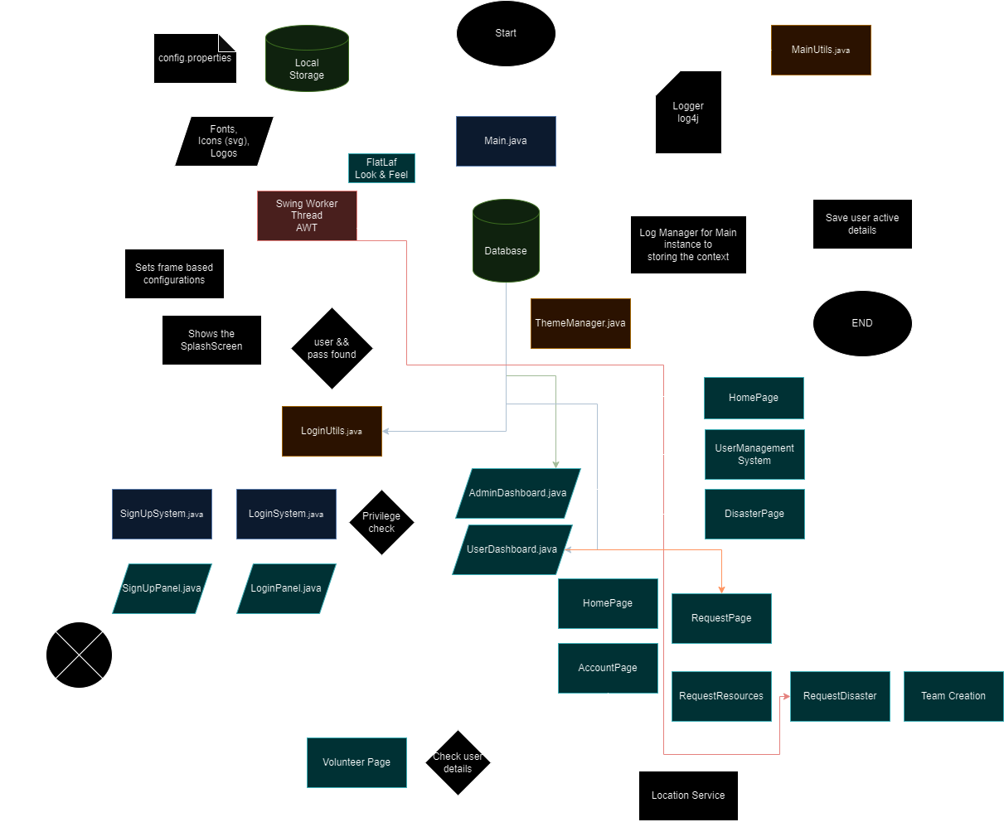

**IMPLEMENTATION**

*Code:*

*Main.java*

* Purpose: Main.java serves as the entry point of the application. It handles the initialization of the main user interface (UI), theme settings, splash screen display, and application logging. This file orchestrates the initial loading of the application and manages the main frame that contains the rest of the UI components.
* Key Methods:
  + setIcon(): This method sets the application icon for the provided JFrame using an SVG logo, applying appropriate color filters to enhance visibility.
  + showSplashScreen(): This method displays a splash screen while the application is loading, and subsequently initializes the login system once the loading is complete.
  + setFont(): This method is responsible for loading and registering custom fonts for the application from the resource files, enhancing the overall visual appearance.
  + setUp(): This method prepares the application environment by setting up logging and displaying the splash screen during the startup process.
  + main(): This is the entry point for the application, which initiates the setup process and launches the application.
    - public static void main(String[] args) {

setUp();

}

* + Main(): This constructor configures the properties of the main application frame, including setting the title and adding a window listener for session management upon closing.

Code:   
package org.burnknuckle;

import com.formdev.flatlaf.FlatDarkLaf;

import com.formdev.flatlaf.FlatLightLaf;

import com.formdev.flatlaf.extras.FlatSVGIcon;

import org.apache.logging.log4j.LogManager;

import org.apache.logging.log4j.Logger;

import org.burnknuckle.utils.Database;

import javax.swing.*;

import java.awt.*;

import java.awt.event.WindowAdapter;

import java.awt.event.WindowEvent;

import java.io.InputStream;

import java.sql.Timestamp;

import java.util.HashMap;

import java.util.Map;

import java.util.Objects;

import static org.burnknuckle.utils.MainUtils.*;

import static org.burnknuckle.utils.ThemeManager.currentTheme;

import static org.burnknuckle.utils.Userdata.getUsername;

public class Main {

private static JFrame mainFrame;

public static boolean rememberMeCheck = false;

private static JFrame splashFrame;

public static final Logger logger = LogManager.getLogger(Main.class.getName());

public static void setIcon(JFrame frame) {

FlatSVGIcon.ColorFilter colorFilter = FlatSVGIcon.ColorFilter.getInstance()

.add(Color.black, Color.black, Color.white)

.add(Color.white, Color.white, Color.black);

FlatSVGIcon logoSvg = new FlatSVGIcon(Objects.requireNonNull(Main.class.getResource("/icons/logo.svg")));

logoSvg.setColorFilter(colorFilter);

frame.setIconImage(logoSvg.getImage());

}

private void showSplashScreen() {

splashFrame = new JFrame();

setIcon(splashFrame);

splashFrame.setDefaultCloseOperation(JFrame.DO_NOTHING_ON_CLOSE);

splashFrame.setSize(600, 600);

splashFrame.setLocationRelativeTo(null);

splashFrame.setUndecorated(true);

ImageIcon splashIcon = new ImageIcon(Objects.requireNonNull(Main.class.getClassLoader().getResource("Common/introImage.jpeg")));

JLabel splashLabel = new JLabel(new ImageIcon(splashIcon.getImage().getScaledInstance(splashFrame.getWidth(), splashFrame.getHeight(), Image.SCALE_SMOOTH)));

splashLabel.setHorizontalAlignment(SwingConstants.CENTER);

splashLabel.setVerticalAlignment(SwingConstants.CENTER);

splashFrame.getContentPane().add(splashLabel);

splashFrame.setVisible(true);

SwingWorker<Void, Void> worker = new SwingWorker<>() {

@Override

protected Void doInBackground() throws InterruptedException {

Thread.sleep(3000);

initializeLoginSystem(mainFrame);

return null;

}

@Override

protected void done() {

splashFrame.dispose();

mainFrame.setVisible(true);

}

};

worker.execute();

}

private static void setFont() {

try {

GraphicsEnvironment ge = GraphicsEnvironment.getLocalGraphicsEnvironment();

InputStream spaceGrotesk = Main.class.getClassLoader().getResourceAsStream("fonts/Inter.ttf");

InputStream inter = Main.class.getClassLoader().getResourceAsStream("fonts/SpaceGrotesk.ttf");

if (spaceGrotesk != null) {

Font spaceGroteskFont = Font.createFont(Font.TRUETYPE_FONT, spaceGrotesk);

ge.registerFont(spaceGroteskFont);

}

if (inter != null) {

Font interFont = Font.createFont(Font.TRUETYPE_FONT, inter);

ge.registerFont(interFont);

}

} catch (Exception e) {

logger.error("Error in: %s".formatted(getStackTraceAsString(e)));

}

}

public static void setUp() {

setLoggerContext();

SwingUtilities.invokeLater(() -> {

try {

setFont();

Main resQit = new Main("ResQit");

resQit.showSplashScreen();

logger.info("App Loaded Successfully!");

} catch (Exception e) {

logger.error("Error in: %s".formatted(getStackTraceAsString(e)));

}

});

}

public static void main(String[] args) {

setUp();

}

public Main(String name) {

try {

if (Objects.equals(currentTheme, "dark")) {

UIManager.setLookAndFeel(new FlatDarkLaf());

} else if (Objects.equals(currentTheme, "light")) {

UIManager.setLookAndFeel(new FlatLightLaf());

}

} catch (UnsupportedLookAndFeelException ex) {

logger.error("Error in: %s".formatted(getStackTraceAsString(ex)));

}

mainFrame = new JFrame();

setIcon(mainFrame);

mainFrame.setTitle(name);

mainFrame.setDefaultCloseOperation(JFrame.EXIT_ON_CLOSE);

mainFrame.addWindowListener(new WindowAdapter() {

@Override

public void windowClosing(WindowEvent e) {

super.windowClosing(e);

String username = getUsername();

if (username != null){

Map<String, Object> lastLogin = new HashMap<>();

lastLogin.put("last_login",new Timestamp(System.currentTimeMillis()));

lastLogin.put("is_active",false);

try {

Database db = Database.getInstance();

db.connectDatabase();

db.updateData12(0, username,lastLogin);

} catch (Exception x){

logger.error("Error in: %s".formatted(getStackTraceAsString(x)));

}

}

}

});

mainFrame.setSize(new Dimension(1400, 900));

mainFrame.setMinimumSize(new Dimension(1400, 900));

mainFrame.setLocationRelativeTo(null);

mainFrame.setVisible(false);

addThemeSelectorMenu(mainFrame);

}

}

**Utilities Folder:**

MainUtils.java

* Purpose: MainUtils.java provides utility functions that assist in managing application settings, user sessions, and theme selection. It facilitates the loading of user preferences, logging configurations, and UI theme management to enhance user experience and maintain application consistency.
* Key Methods:
  + clearProperties(): This method clears user-related properties such as credentials and the last clear time from the config.properties file and saves the updated properties.
  + setLoggerContext(): This method sets up the logging configuration by loading the Log4j configuration file from the classpath, ensuring that all application logs are properly managed.
  + RememberMeReader(): This method reads stored user credentials from the config.properties file to enable automatic login if the "Remember Me" feature is activated and the stored credentials are valid.
  + getStackTraceAsString(): This utility method converts an exception’s stack trace into a string format for logging purposes, improving error reporting capabilities.
  + initializeLoginSystem(): This method initializes the login system by calling RememberMeReader, launching the login interface if the user is not already authenticated.
  + addThemeSelectorMenu(): This method creates and adds a theme selection menu to the main application frame, allowing users to switch between dark and light themes, thus enhancing the application's aesthetic flexibility.

*Database.java*

* Purpose: Manages all database interactions, providing methods for CRUD operations and data validation.
* Key Methods:
  + updateData(): Updates records in the specified table based on a map of data.
  + insertData(): Inserts new records into the specified table using the provided data.
  + deleteData(): Deletes records from the specified table where the given column matches the specified value.
  + getAllData(): Retrieves all records or specific columns from the table and returns them as a list of maps.
  + checkForDuplicateDisaster(): Checks for existing disaster entries based on disaster type, name, and start date.
  + checkForDuplicateTeams(): Checks for existing teams based on team name and leader username to prevent duplicates.
  + getTeamsForUser(): Retrieves all teams led by the specified user based on their username.
  + updateData12(): Updates user data in the specified table based on their username and the provided data.
  + getUsernameDetails(): Retrieves detailed information for a specific username from the user table.
  + deleteUserData(): Deletes a user from the database based on their username.
  + isAdmin(): Checks if the specified user has admin privileges in the database.
  + isUser(): Verifies whether the specified username exists in the user table.
  + getConnection(): Establishes a connection to the PostgreSQL database if one isn't already open.
  + closeConnection(): Closes the database connection if it is open.
  + checkTableExists(): Checks if a specific table exists in the database.
  + createTable(): Creates required tables for users, resources, disasters, and teams if they do not exist in the database.
  + convertStringToTimestamp(): Converts a string representation of a date into a Timestamp object.

Code:   
// Import necessary packages for database connection and manipulation

Class Database:

// Declare private static instance variable (singleton pattern)

Declare private static Database instance

// Method to get the singleton instance of the Database class

Method getInstance():

If instance is null:

Create new Database instance

Return instance

// Method to establish a connection to the database

Method connectDatabase():

Try:

// Load database driver (e.g., JDBC)

// Set up connection parameters (database URL, username, password)

// Create a connection object to the database

// If successful, log a message indicating successful connection

Catch Exception:

// Log any exceptions or errors in establishing the connection

// Method to update user login data in the database

Method updateData12(int userID, String username, Map<String, Object> loginData):

Try:

// Connect to the database by calling connectDatabase()

// Prepare SQL statement for updating the user's last login timestamp and active status

// Bind parameters (username, last login timestamp, is_active status)

// Execute the SQL update command

// If successful, log a message indicating the update success

Catch Exception:

// Log any exceptions or errors encountered during the update

*ThemeManger.java*

* Purpose: Manages theme settings for the application, allowing dynamic updates and customization of UI colors.
* Key Methods:
  + UpdateADPThemeData(): Updates the theme data based on the provided theme (dark, light, or default).
  + getColorFromHex(): Converts a hex color string into a Color object, supporting both RGB and ARGB formats.
  + addThemeChangeListener(): Adds a listener that will be notified when the theme changes.
  + notifyThemeChangeListeners(): Notifies all registered listeners of a theme change.
  + checkForThemeChange(): Checks if the theme has changed and notifies listeners if it has.
  + setButtonHoverAndActiveColors(): Sets hover and active colors for a button based on the provided theme colors.
  + readTheme(): Reads the current theme from a configuration file.
  + writeTheme(): Writes the current theme to a configuration file.

*Userdata.java*

* Purpose: Manages user-related data, including the global username and retrieving user details from the database.
* Key Methods:
  + getUsername(): Returns the current global username.
  + setUsername(): Sets the global username to the provided name.
  + getUserDataFromDatabase(): Retrieves user details from the database based on the global username.

*Resources.java:* Provides access to image resources used in the application, including icons for buttons and visual elements.

*LoginUtils.java*

* Purpose: Handles user authentication and user registration functionalities, including credential checks and panel size updates for the login and signup interfaces.
* Key Methods:
  + UserCredentialsCheck(): Validates user credentials and returns the user's privilege level or an error message.
  + SignUpUser(): Registers a new user with the provided data, checking for existing usernames.
  + updatePanelSizes(): Adjusts the sizes and positions of the login/signup panels based on the current page and new dimensions.

**UI Folder:**

*LoginPanel.java*

* Purpose: Implements the user interface for the login screen, handling user input and interaction with the login system.
* Key Methods:
  + initialize(): Sets up the UI components and layout for the login panel.
  + validateFields(): Validates user input and enables or disables the login button based on input criteria.
  + getPanel(): Returns the login overlay panel for use in the main application.

*SignUpPanel.java*

* Purpose: Implements the user interface for the sign-up screen, handling user input and interaction with the sign-up system.
* Key Methods:
  + initialize(): Sets up the UI components and layout for the sign-up panel, including text fields, labels, buttons, and progress bars.
  + SignReloadImage(): Loads and scales the logos based on the current theme, handling errors if images are not found.
  + getPanel(): Returns the sign-up overlay panel for use in the main application.

*UserDashboardPanel.java*

* Purpose: Implements the user interface for the user dashboard, providing access to various features and functionalities based on user roles.
* Key Methods:
  + initialize(): Sets up the UI components and layout for the user dashboard, including menus, panels, and action listeners.
  + updateUserData(): Fetches and displays the current user data and statistics relevant to the logged-in user.
  + refreshDashboard(): Refreshes the dashboard view and updates the displayed information based on user interactions.

*AdminDashboardPanel.java*

* Purpose: Implements the user interface for the admin dashboard, allowing administrators to manage users, view reports, and customize the interface according to the application's theme.
* Key Methods:
  + AdminDashboardPanel(): Constructor that initializes the admin dashboard, sets the layout, and adds a component listener to handle resizing events.
  + updateThemeColors(): Updates the color scheme of the admin dashboard based on the selected theme (dark or light).
  + updateComponentSizesAndPositions(): Adjusts the sizes and positions of the UI components whenever the window is resized.
  + removeMenu(): Toggles the visibility of the side menu panel and updates the display accordingly.
  + createAdminBoard(): Constructs the admin dashboard's user interface, including the menu, sidebar buttons, and main content areas.
  + createSidebarButton(): Creates a sidebar button with the given text and adds action listeners for functionality.
  + showDateTimePicker(): Displays a dialog for the user to select a date and time, then updates the specified cell in the given table with the selected value.

**Controllers Folder:**

*LoginSystem.java*

* Purpose: Manages the login functionality, including user authentication, transitions between the login and sign-up interfaces, and storing user credentials for the "Remember Me" feature.
* Key Methods:
  + LoginSystem(): Initializes the login system with the main application frame and sets up the user interface.
  + rememberMeSaver(): Saves the user's credentials to a properties file to enable the "Remember Me" functionality, updating or creating the config.properties file as needed.
  + BtwLS(): Switches between the login and sign-up panels, managing the overlay and resizing components dynamically based on the main frame's dimensions.
  + initialize(): Sets up the initial UI components, including the layered panes and background image, while loading the login and sign-up panels.
  + Login(): Handles the user login process, validating credentials, updating the last login timestamp, and transitioning to the appropriate dashboard.
  + showWarning(): Displays a warning message for a limited time, providing feedback to the user for invalid login attempts or other notifications.

*SignUpSystem.java*

* Purpose: Manages the sign-up process for users, validating input fields and handling user registration.
* Key Methods:
  + SignUp(): Validates user input and processes the sign-up by storing user data and navigating to the user dashboard upon successful registration.
  + isValidEmail(): Checks if the provided email address matches the required format for validity.
  + showWarning(): Displays warning messages to the user for invalid input, hiding the message after a specified duration.
  + validateFields(): Validates the fields for username and password, updating visual indicators for strength and matching criteria.

**SubParts Folder:**

*AdminUsersLabel.java (In progress)*

*ColumnFilterDialog.java*

* Purpose: Provides a dialog window for users to filter and select columns from a given dataset, with the ability to retain column order based on priority.
* Key Methods:
  + ColumnFilterDialog(): Initializes the dialog with checkboxes for each column, allowing the user to select or deselect columns. The "ID" column is always selected and non-editable.
  + setOrder(): Ensures that the selected columns are sorted according to a pre-defined priority order from the column mapping.

*LoginBgPanel.java: Draws the graphic and maintains a buffer image for the background image for the JPanel.*

*PasswordFieldWithToggle.java: Custom made password field for eye open and close effect.*

**SubPages Folder:**

**Admin Folder:**

*DashboardPanel.java (In Progress)*

*DisasterResourcesPanel.java*

* Purpose: Manages the display and interaction of disaster resources categorized into ongoing, requested, and resolved disasters. It allows administrators to view, edit, save, and delete disaster data.
* Key Methods:
  + createDisasterResourcesPanel(): Constructs the disaster resources panel, organizing tables for resolved, requested, and ongoing disasters, and adds action buttons (edit, save, delete) for user interaction.
  + refreshData(): Fetches the latest disaster data from the database and populates the respective tables based on the disaster status.
  + updateTableModels(): Updates the table models by adjusting the displayed columns based on user selection.
  + addTableButtonListeners(): Adds listeners to handle editing, saving, and deleting disaster records in the tables, ensuring proper updates to the database and the UI.
  + saveButton Action: Saves edited data back to the database and refreshes the table.
  + deleteButton Action: Deletes selected disaster data from the database and removes the row from the table.

*ResourcesStatus.java (In Progress)*

*UsersManagementPanel.java*

* Purpose: Manages the user interface for the administration of users and co-admins. It provides functionalities for viewing, editing, saving, and deleting user records, as well as filtering table columns and refreshing data.
* Key Methods:
  + createUsersCoAdminsPanel(): Constructs the panel that displays tables for admins and users, along with buttons for editing, saving, and deleting entries.
  + updateTableModelsAU(): Updates the table model based on the selected columns and refreshes the data accordingly.
  + refreshDataAU(): Fetches user and admin data from the database and populates the respective tables, distinguishing between user roles.
  + addTableButtonListenersAU(): Attaches listeners to the admin and user tables for edit, save, and delete actions, enabling or disabling buttons based on table state and selected rows.
  + saveButton Action: Updates the database with edited user/admin data, displays a success message, and refreshes the table.
  + deleteButton Action: Deletes the selected user/admin from the database and removes the corresponding row from the table.

*VolunteerManagementPanel.java (in Progress)*

**User Folder:**

*AccountPage.java ->* Purpose: Displays and edits the account details for users and admins.

*HomePage.java (In Progress)*

*RequestDisaster.java*

* Purpose: Manages the disaster request page for users, embedding a JavaFX UI into a Swing application, and applying the appropriate theme based on user preferences.
* Key Methods:
  + createDisasterSubPage(): Embeds a JavaFX panel (JFXPanel) into a Swing JPanel. Loads the UI layout from the requestPage.fxml file and applies the current CSS theme. Registers a theme change listener to dynamically update the UI if the theme is switched.
  + setCSSTheme(): Dynamically sets the CSS theme for the disaster request page. Clears existing stylesheets and applies the relevant stylesheet (requestPage-dark.css or requestPage-light.css) based on the provided theme.
  + SwingUtilities.invokeLater(): Ensures that the JavaFX UI operations (like loading the FXML and setting the scene) run on the correct thread, which is necessary for JavaFX and Swing interoperability.
  + Error handling: If the FXML file cannot be loaded, an error message is logged using the logger with a stack trace for debugging purposes.

*RequestPage.java*

* Purpose: Creates a disaster request interface with sections for resource requests, disaster requests, and team management, featuring interactive buttons that respond to user actions and theme changes.
* Key Methods:
  + createRequestPage(): Initializes the main disaster request panel with interactive labels. Each label allows users to switch between pages (Resource Request, Disaster Request, and Teams). Handles background color changes on hover and click events.
  + updateThemeColors(): Updates the theme colors of the panel and labels dynamically according to the selected theme.
  + resRequestLabel.addMouseListener(): Manages the mouse events for the Resource Request label, including hover effect and navigation to the resource request page on click.
  + disasterAddReqMainLabel.addMouseListener(): Similar to resRequestLabel, it handles mouse events for the Disaster Request label, allowing navigation to the disaster request page.
  + volunteerRegistrationLabel.addMouseListener(): Adds interactivity to the Teams label, allowing users to navigate to the team creation page. It also changes background color on hover and click.

*RequestResources.java*

* Purpose: Manages the resource request form, allowing users to submit requests for various resources needed during disasters. It includes validation for user input and provides feedback upon submission.
* Key Methods:
  + createRequestResourcesSubPage(): Constructs the user interface for the resource request form, including fields for requester information, disaster type, and required resources. It utilizes a background image and rounded borders for aesthetics.
  + clickSubmit(): Gathers user input from the form fields, validates the data, and displays success or error messages based on the validation outcome. It prints the collected data to the console for debugging.
  + validateData(): Checks the provided data for completeness, ensuring that all required fields are filled out. Returns a string containing error messages if validation fails.

*TeamCreationPage.java*

* Purpose: Facilitates the creation of volunteer teams for disaster response, allowing users to input team details and manage team member assignments.
* Key Methods:
  + createTeamCreationPage(): Constructs the user interface for creating a new team, including fields for team name, disaster type, and member selection. It organizes the layout using a grid system for a clean presentation.
  + clickCreateTeam(): Gathers input from the form fields and validates the data before creating the team. It provides feedback on success or error messages based on the validation results.
  + validateTeamData(): Validates the input data for the team creation form, ensuring that all required fields are filled and that the team name meets specified criteria. Returns a string with error messages if validation fails.

*VolunteerRegistration.java*

* Purpose: Manages the volunteer registration process, allowing users to read and acknowledge a disaster volunteer pledge before submitting their registration details to the database.
* Key Methods:
  + createVolunteerRegistrationSubPage(): Constructs the user interface for the volunteer registration form, including a display of the disaster volunteer pledge, and sets up the layout using a card layout for navigation.
  + clickSubmit(): Handles the submission of the registration form, storing the volunteer's registration time and privilege in the database. It provides success feedback upon successful registration and navigates back to the home page.

**SCREENSHOTS**

Splash Screen:  


Icon (Dark & Light):

 

Login Page (Dark & Light):

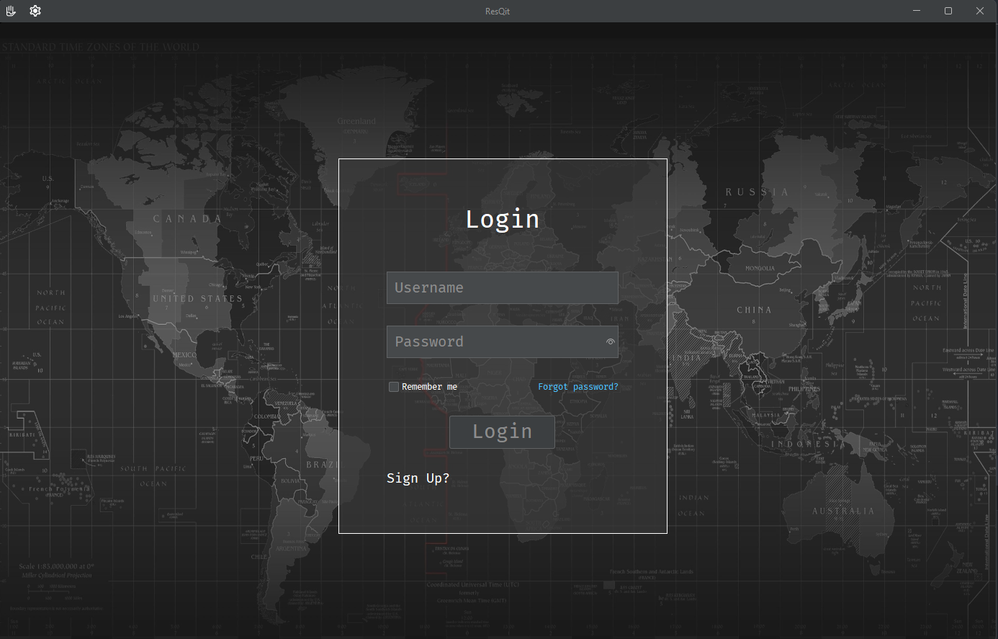 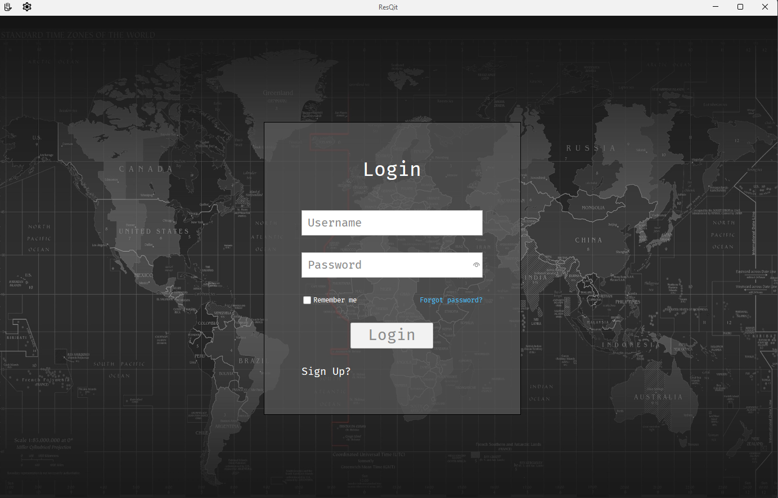

Sign Up Page (Dark & Light) :

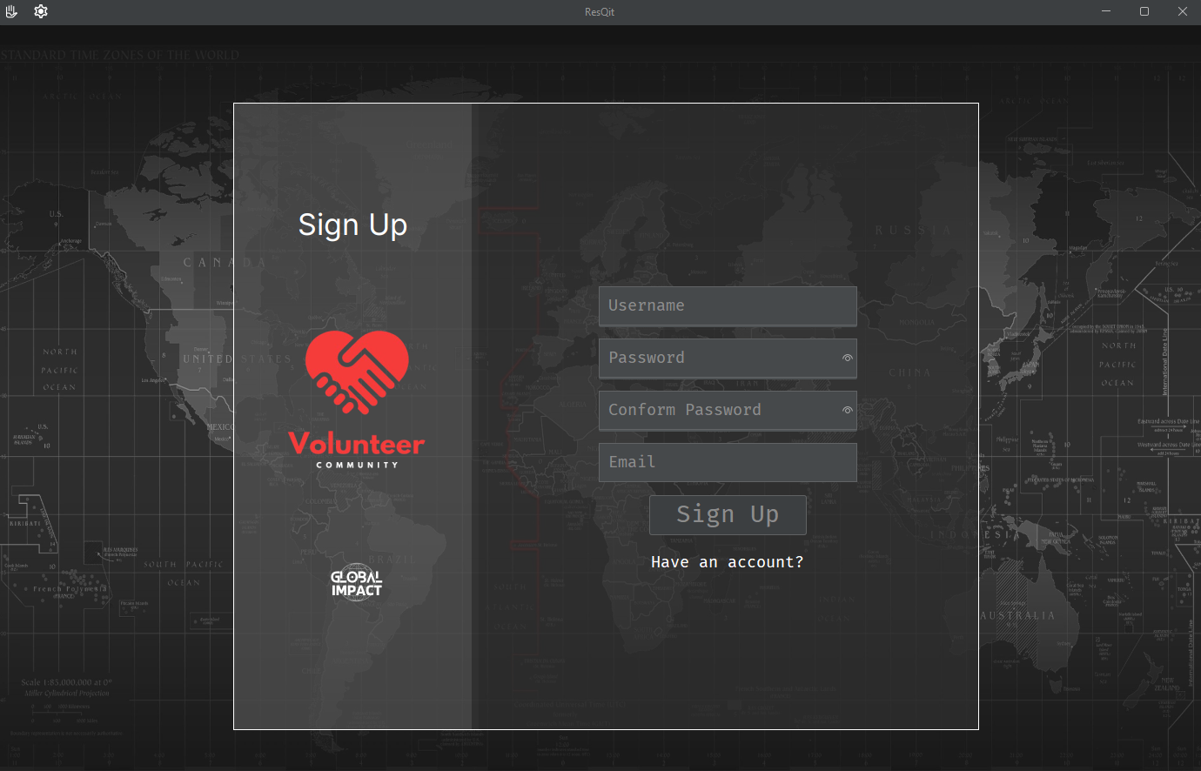 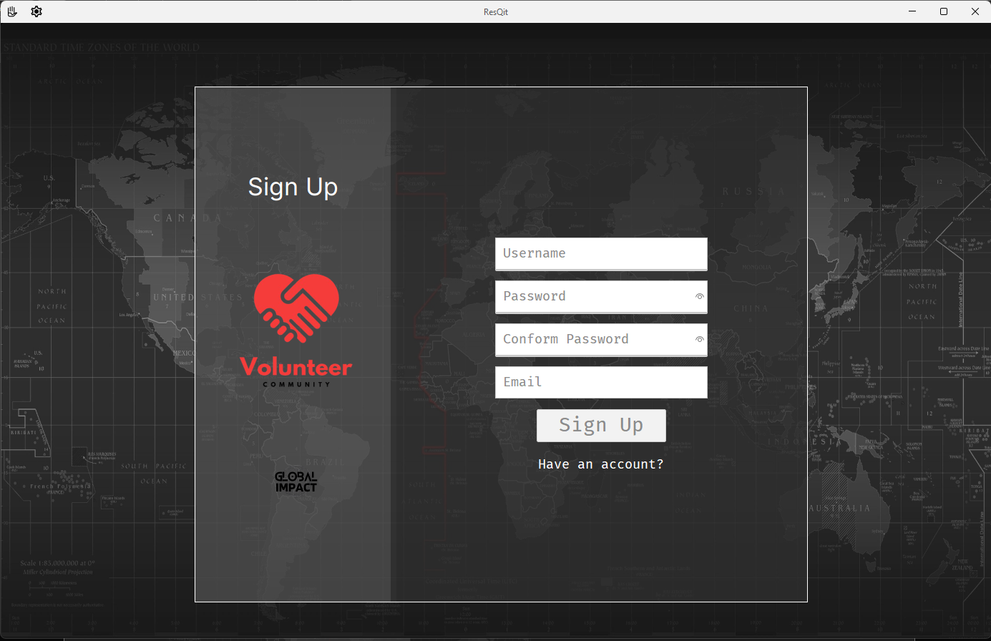

Request Page (Dark & Light) [Vol] :

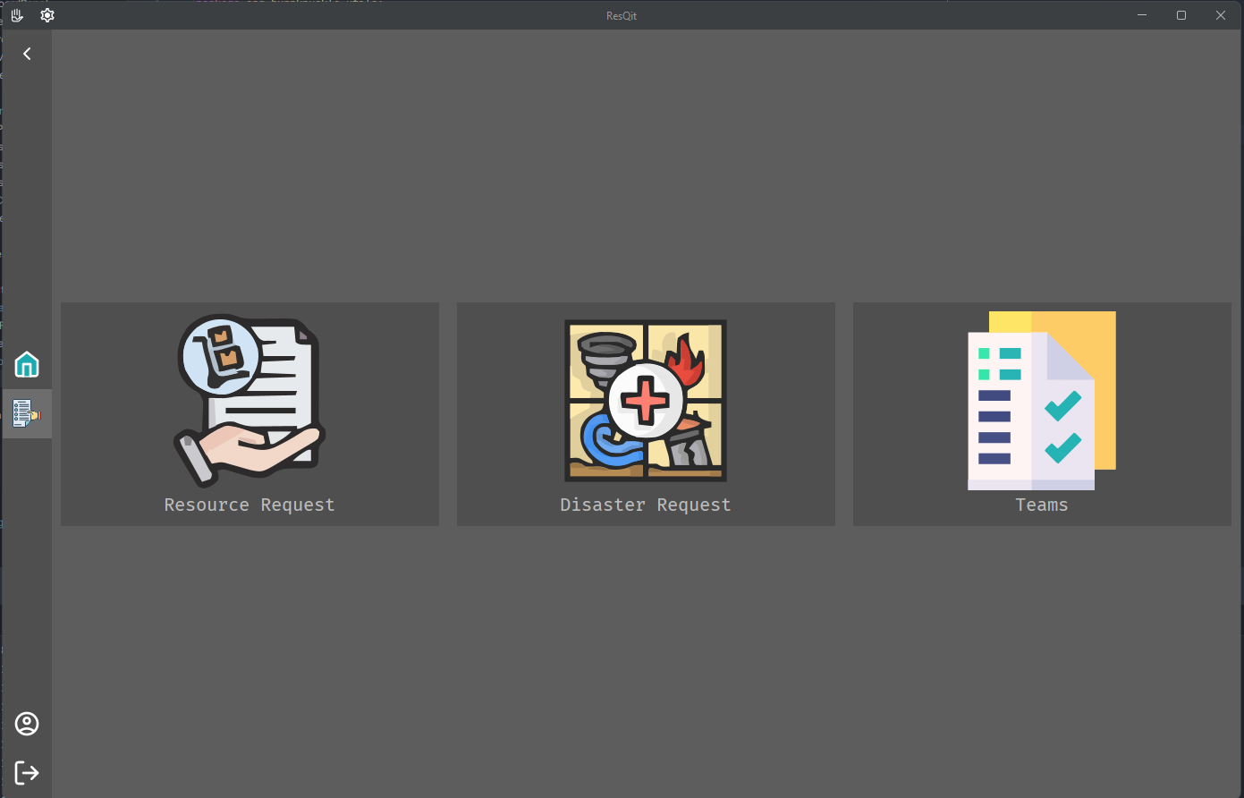 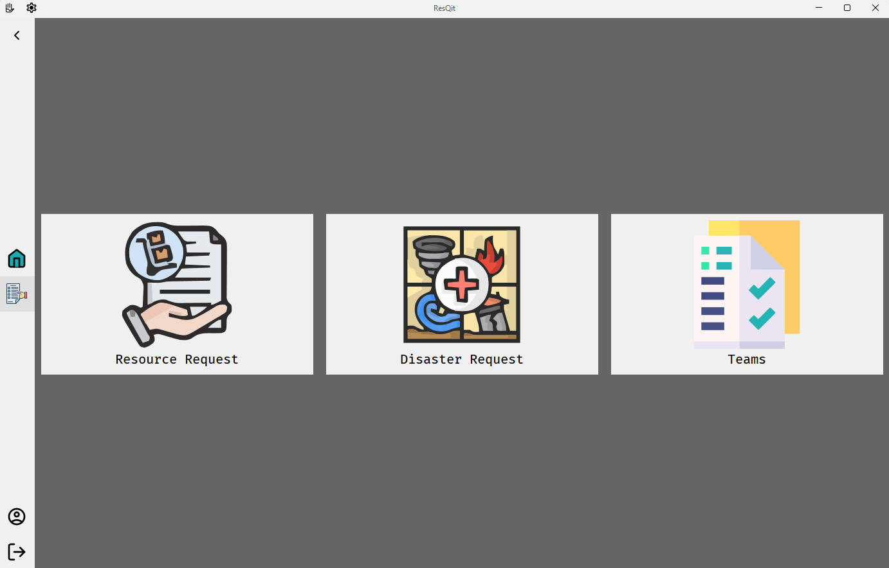

Account Page (Dark & Light):

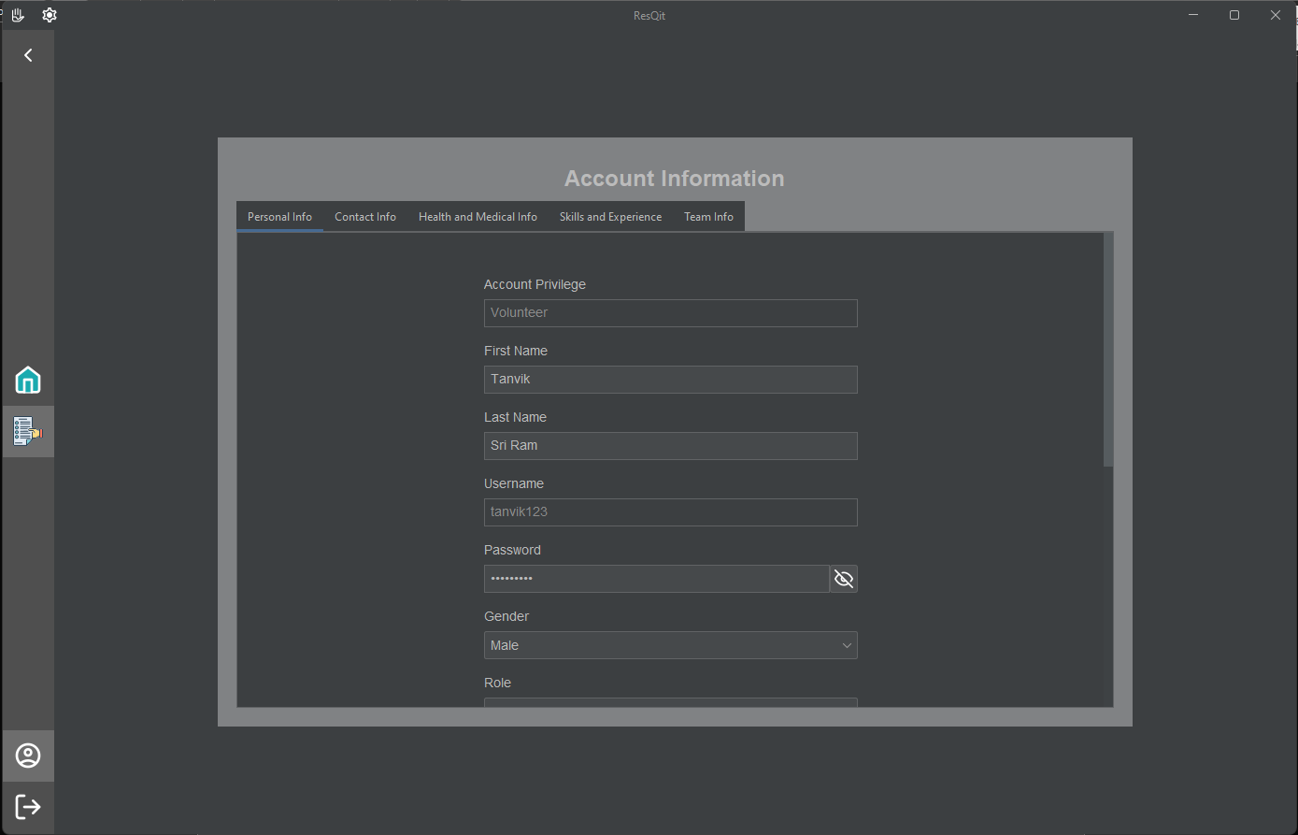 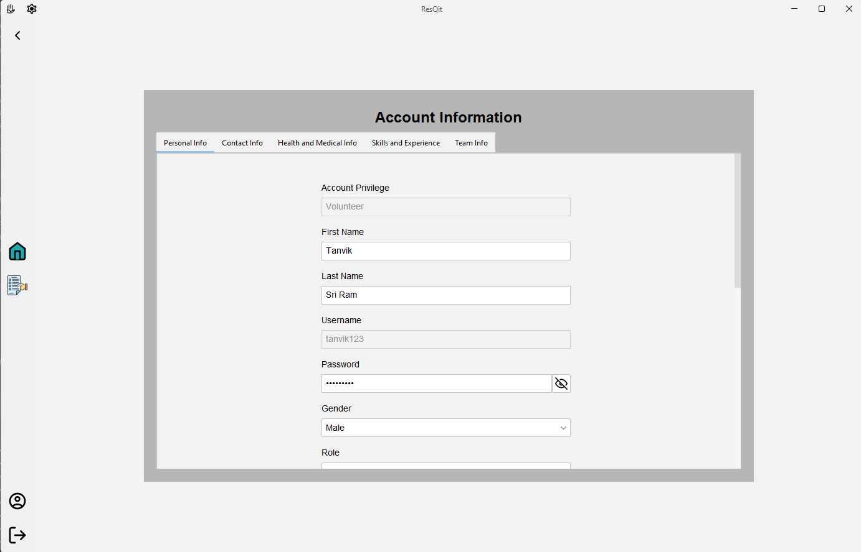

Disaster Request Page (Dark & Light):

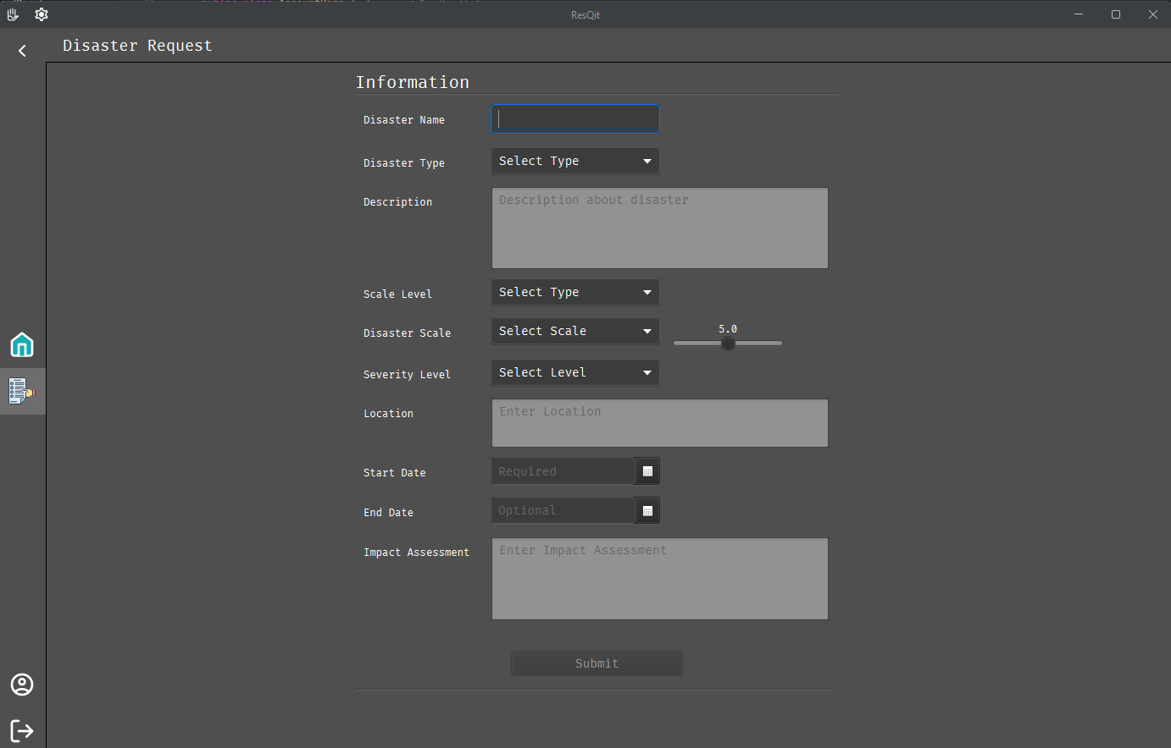 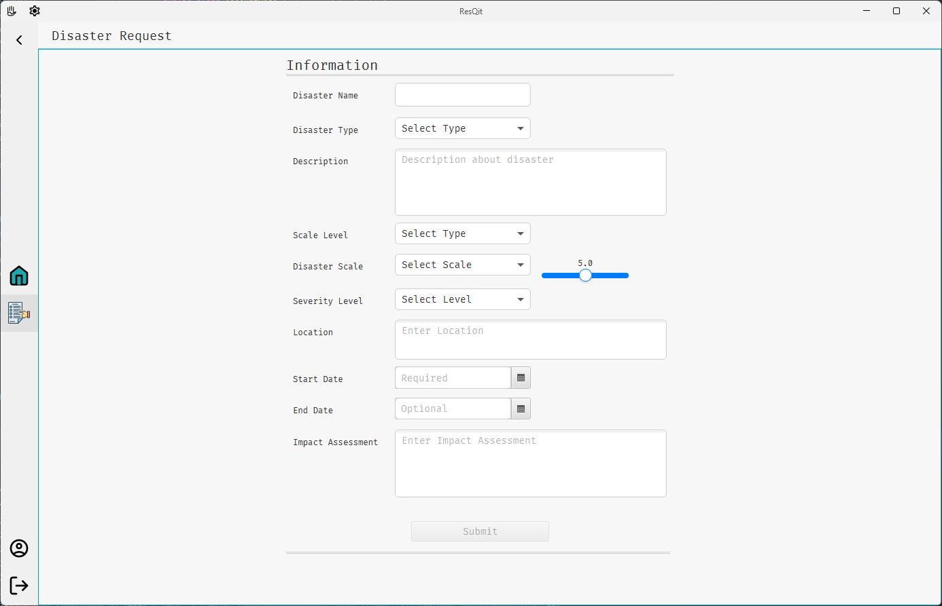

Team Creation Page (Dark & Light):

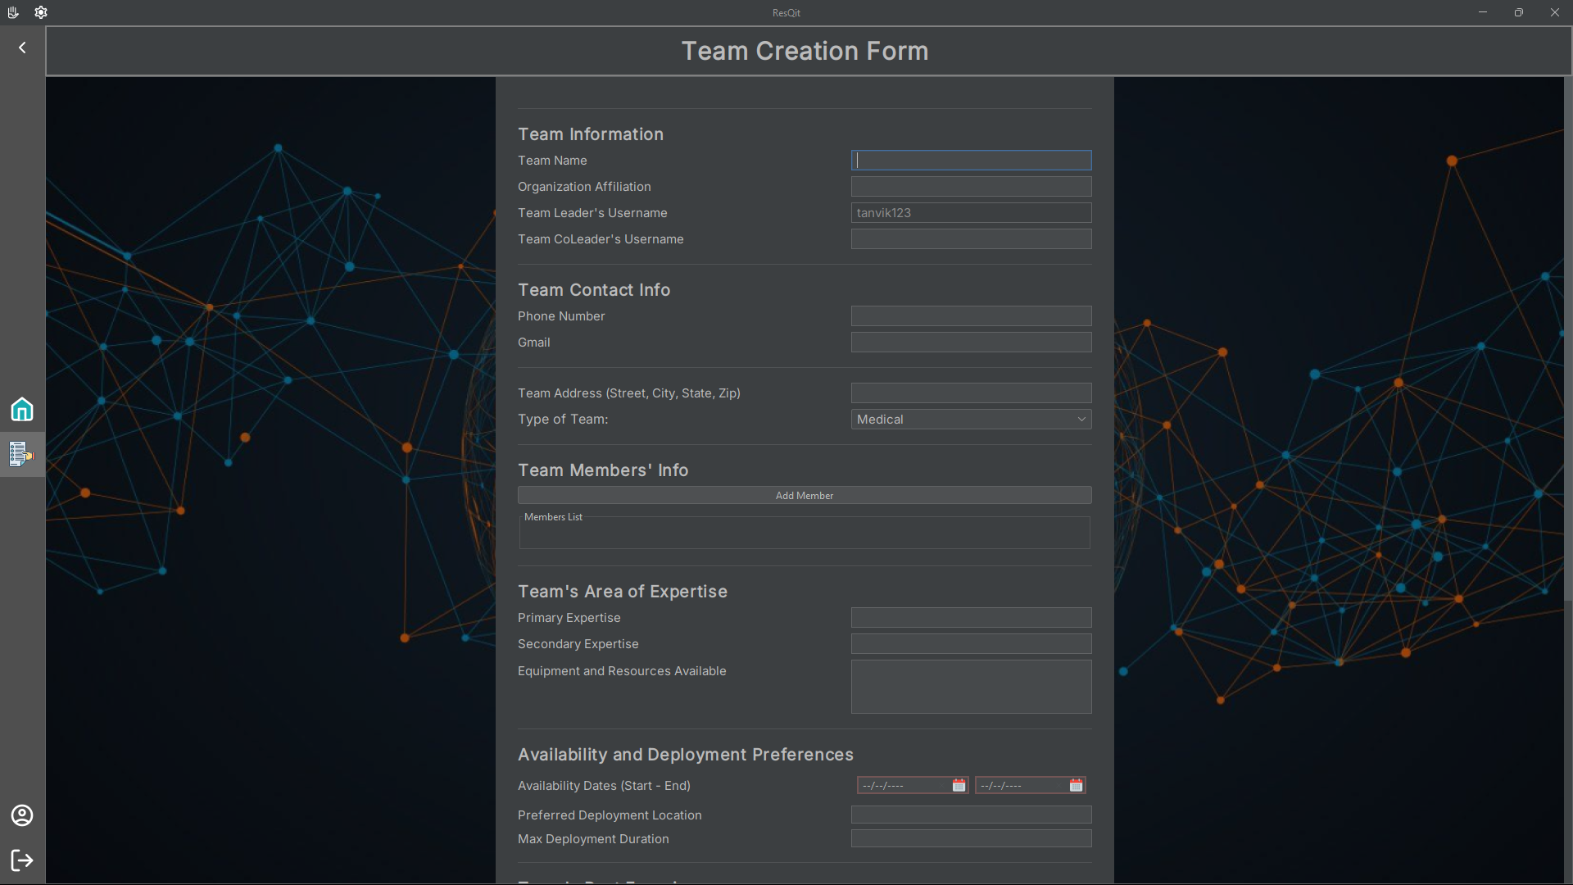 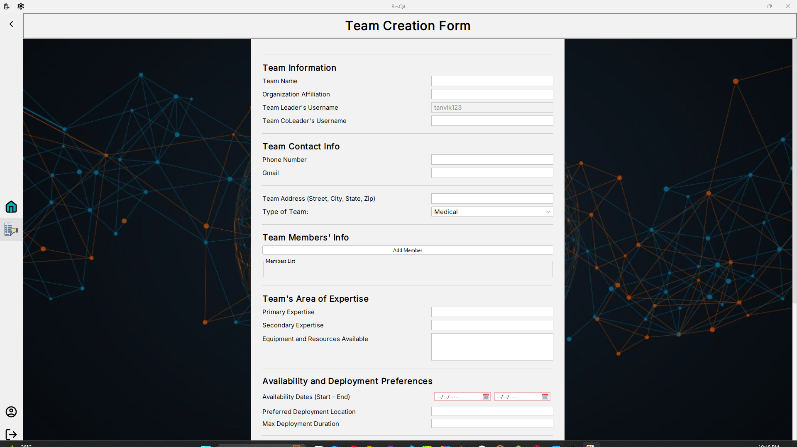

Admin Side Panel (Dark & Light):

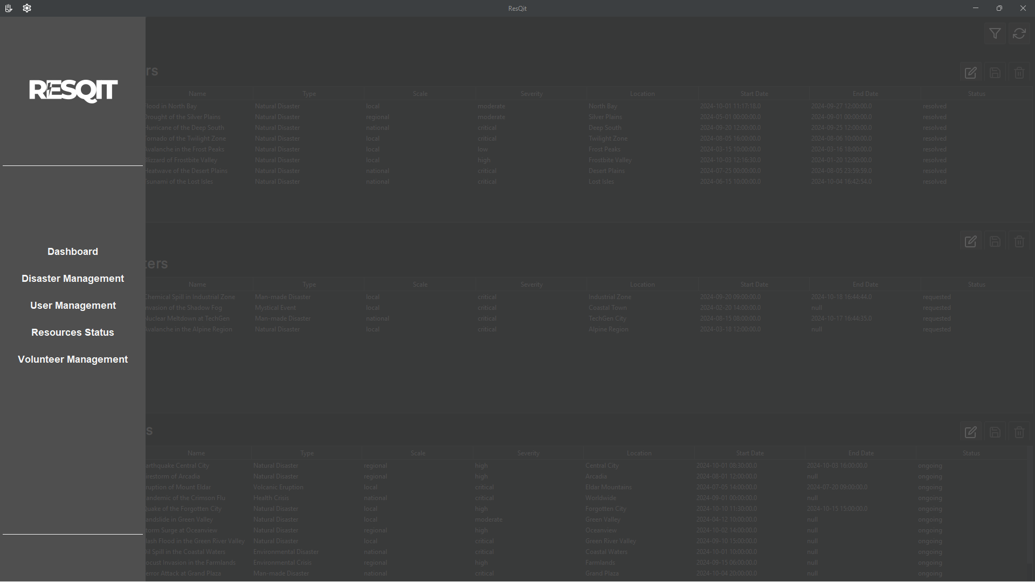 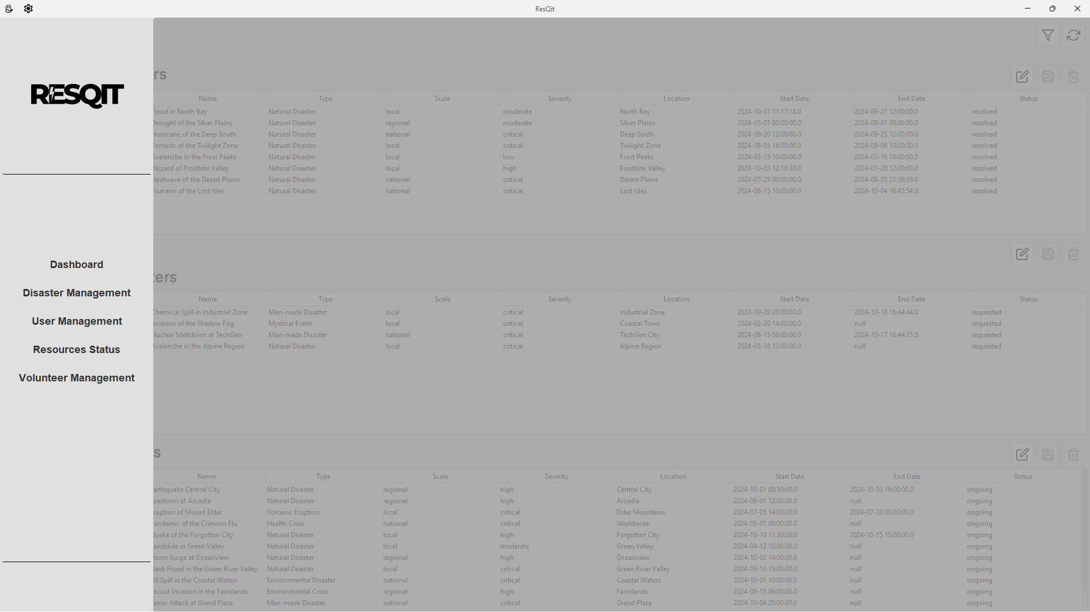

Disaster Admin Page (Dark & Light):

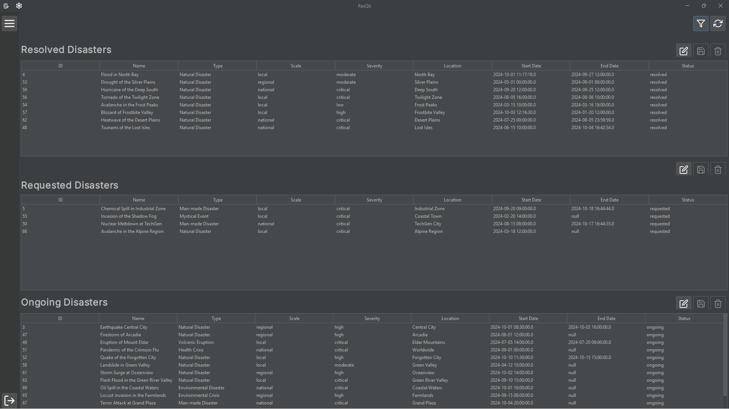 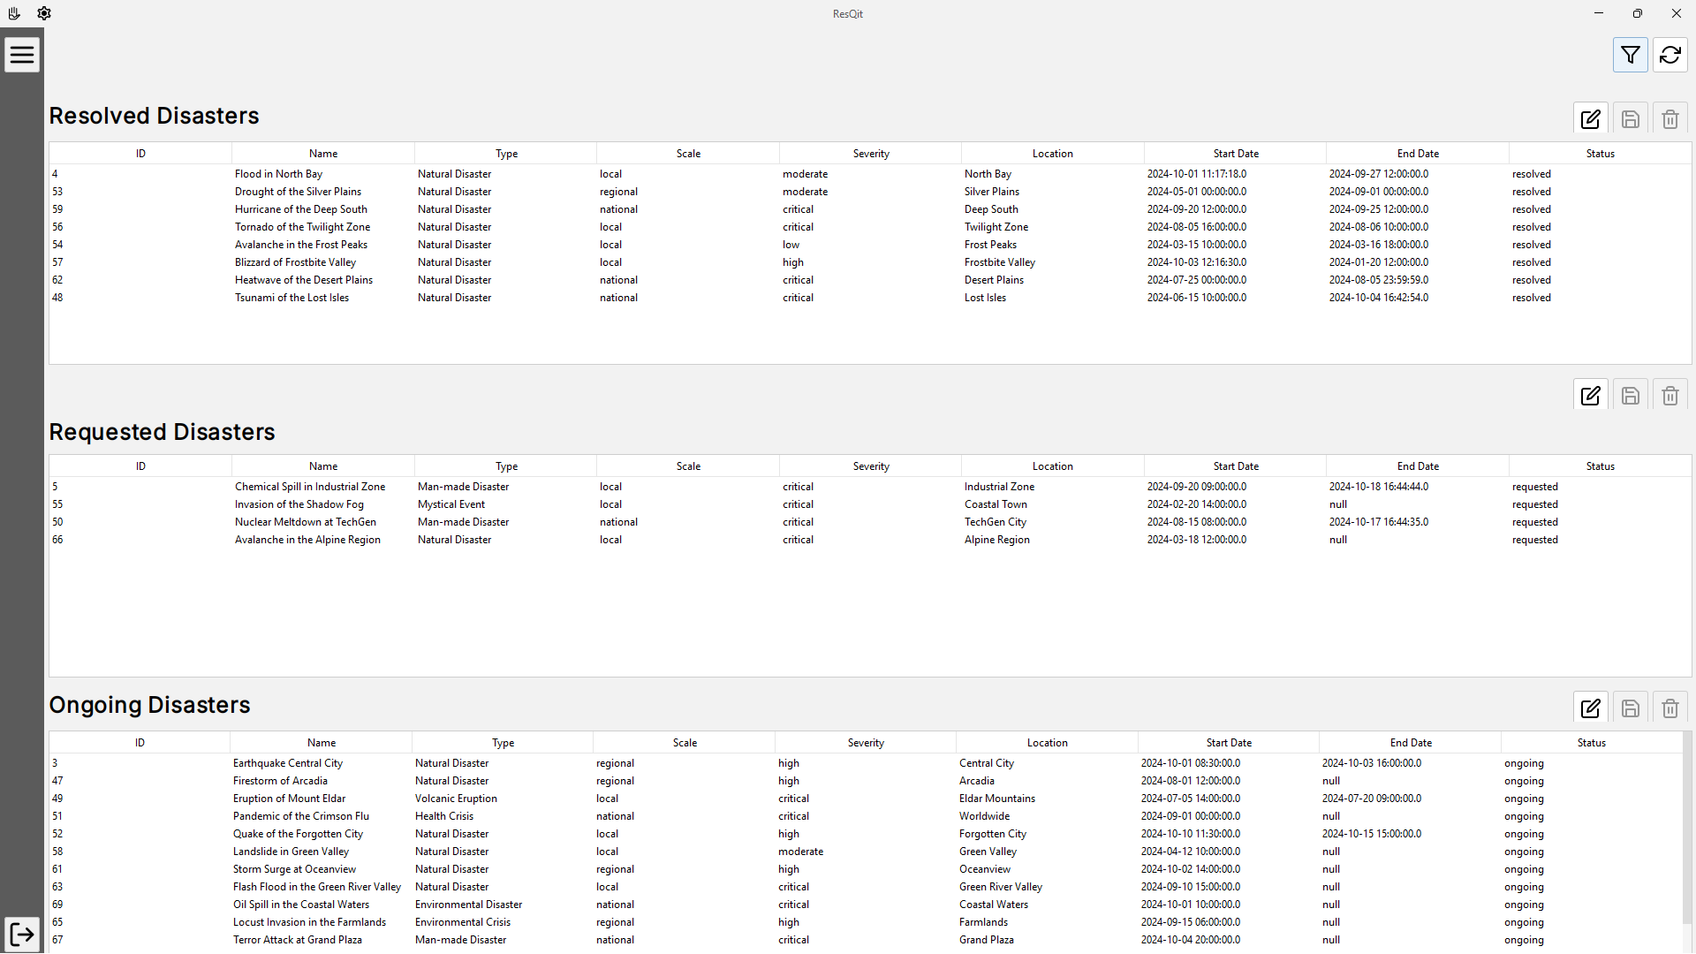

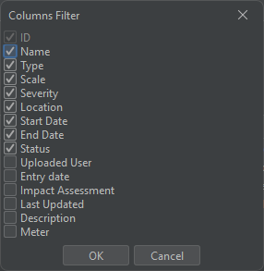 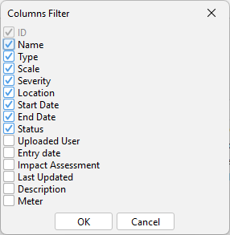

User Management Admin Page (Dark & Light):

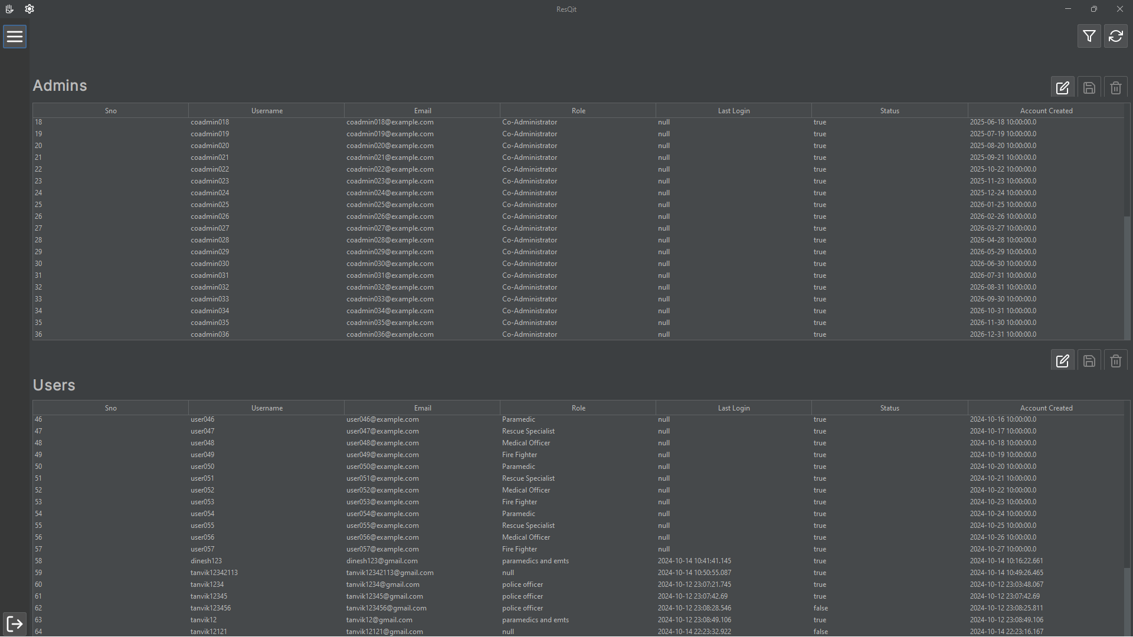 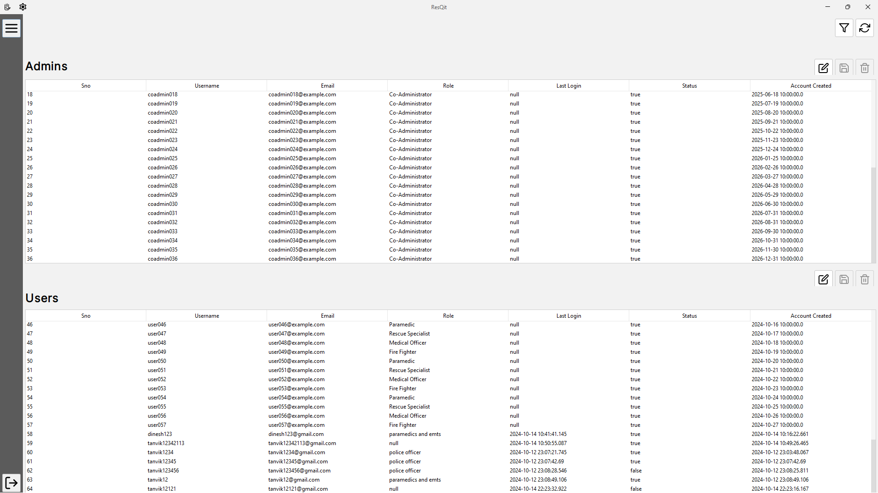

Volunteer’s Page (Dark & Light):

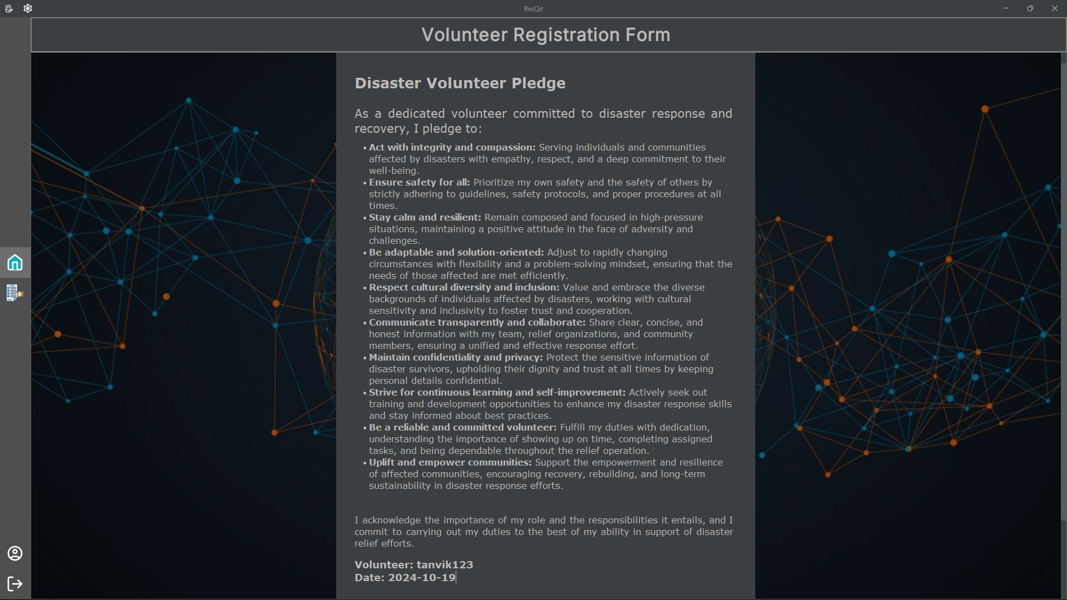 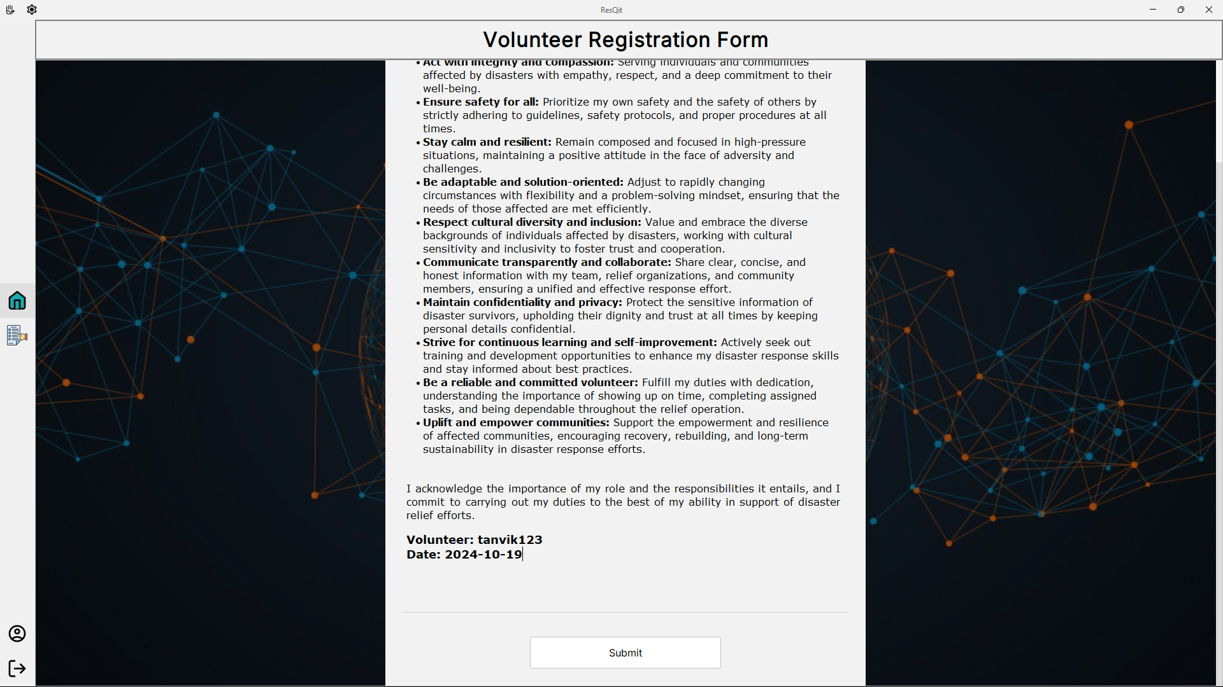

User’s Home Page (Dark & Light):

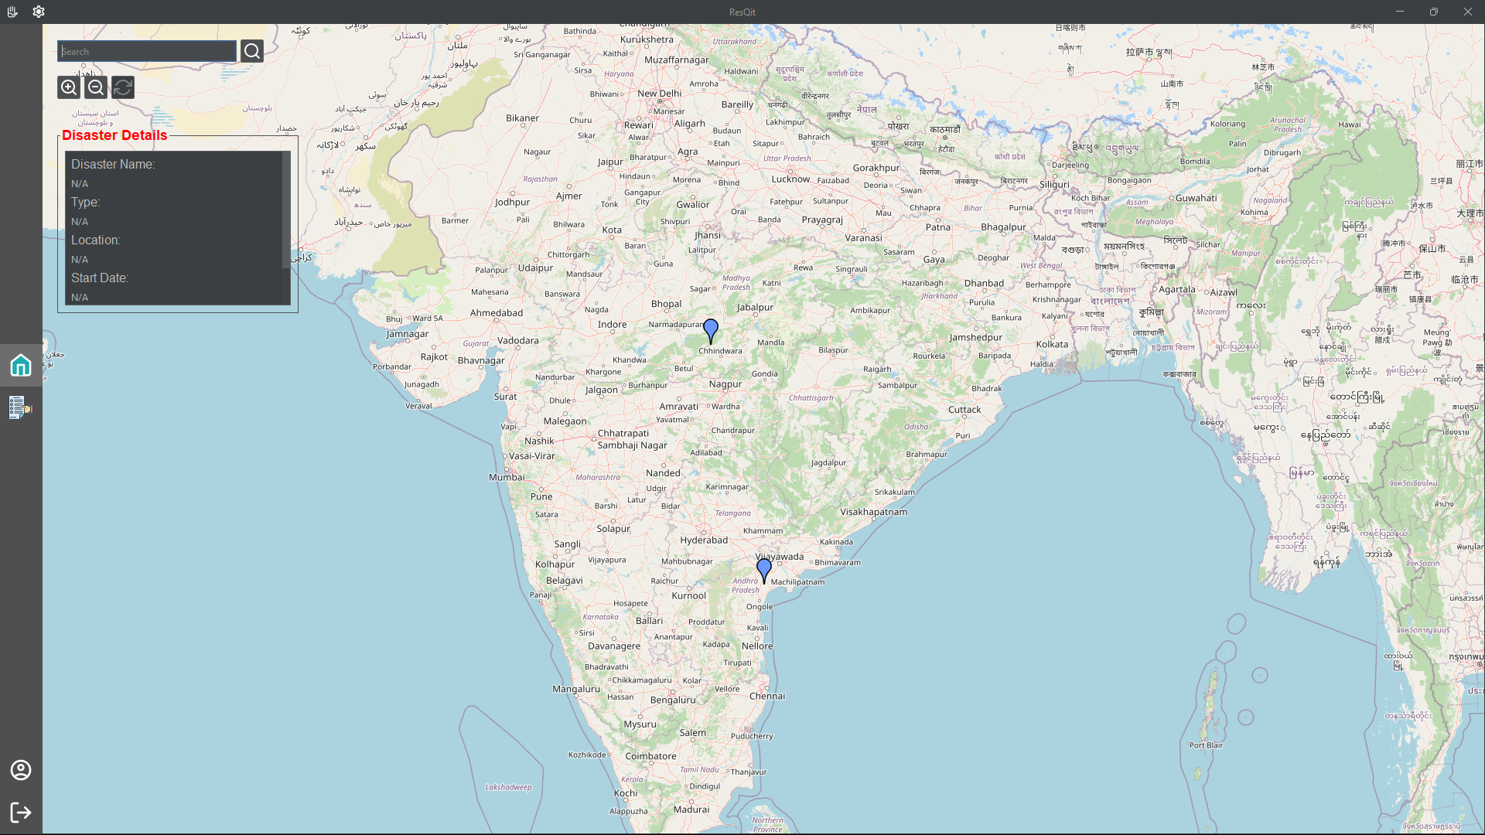 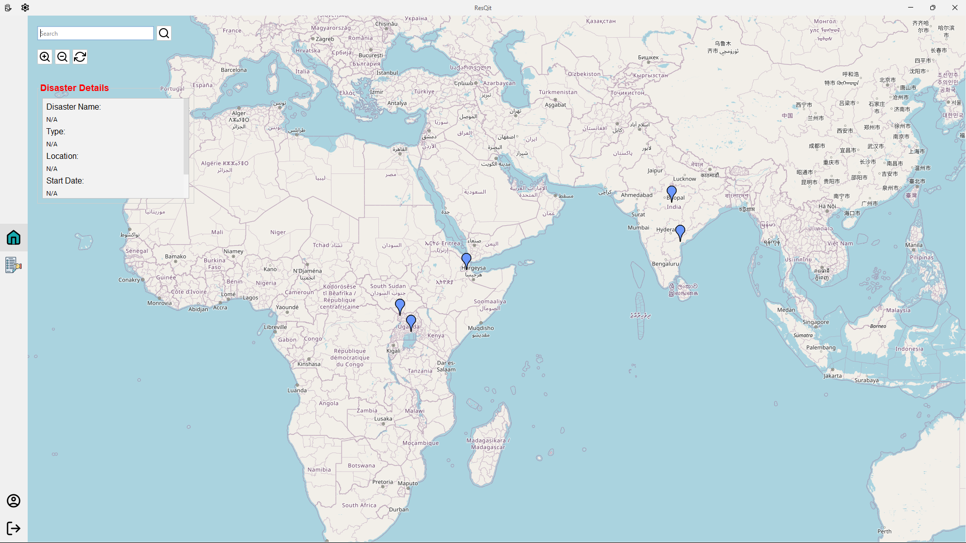**CONCLUSION**

The Disaster Response Coordination project successfully addresses the critical need for efficient resource management and coordination during disaster situations. Through the development of a comprehensive system that includes features such as user registration, team creation, and resource request management, the project enhances the ability of volunteers and administrators to respond effectively to emergencies.

The key components of the project, including the User Dashboard and the various forms for team creation and resource requests, provide a user-friendly interface that streamlines the processes of volunteer management and resource allocation. The use of a database for storing user information and requests ensures data integrity and accessibility, enabling swift decision-making during crises.

Furthermore, this project has offered valuable insights into software design and development, particularly in utilizing Java and its libraries to create a functional and interactive graphical user interface. The implementation of best practices in user experience design ensures that the application is not only efficient but also intuitive for users.

In conclusion, the Disaster Response Coordination project lays a solid foundation for further enhancements, such as integrating real-time communication features and expanding the system to accommodate a broader range of disaster scenarios. By continuing to refine and enhance the platform, we can significantly improve the overall effectiveness of disaster response efforts, ultimately saving lives and supporting affected communities in their recovery.

**EVALUATION SHEET**

**Reg.No: URK23CS1261**

**Name: TANVIK SRI RAM REDDY**

**Course code: 23CS2032**

**Course Name: Object Oriented Programming**

|  |  |  |  |
| --- | --- | --- | --- |
| **S.No** | **Rubrics** | **Maximum Marks** | **Marks Obtained** |
| 1 | Industrial Certification | 10 |  |
| 2 | Real – Time Application Design | 30 |  |
| Total | | 40 |  |

|  |  |  |  |  |
| --- | --- | --- | --- | --- |
| **Rubrics** | **Excellent** | **Good** | **Average** | **Below Average** |
| **Classes and Inheritance** |  |  |  |  |
| **Concept Used** |  |  |  |  |
| **GUI** |  |  |  |  |
| **Database** |  |  |  |  |
| **Innovation** |  |  |  |  |
| **Presentation and Viva** |  |  |  |  |
| **Report** |  |  |  |  |

**Signature of the Faculty-in-charge**